PRESS RELEASE or Letter to Government/Business Leader

For Publication on Thursday June 7th, 2018

GLOBAL MANAGEMENT CONSULTING PROFESSIONAL BODY CELEBRATES INTERNATIONAL CONSULTANTS’ DAY
The International Council of Management Consulting Institutes (ICMCI), in unison with its members and management consultants from around the world including insert IMC Name Here, recognizes and celebrates today as ‘International Consultants’ Day’.

Today as we celebrate the genesis and accomplishments of the consulting profession, we also celebrate our clients and stakeholders for their engaging support and entrusting us with their business and institutional health.

The International Council of Management Consulting Institutes (ICMCI), its 56,000 members and the sector in general have a lot to celebrate, as yesterday marked the ‘one year’ anniversary of the very first ISO standard for a consulting service. This international standard, entitled ‘ISO 20700: Guidelines for Management Consultancy Services’, was championed by ICMCI, throughout its formative and approval stages. The Certified Management Consultant (CMC) designation in particular, is a client’s guarantee of excellence in a largely unregulated industry.

How could YOU use a Certified Management Consultant?
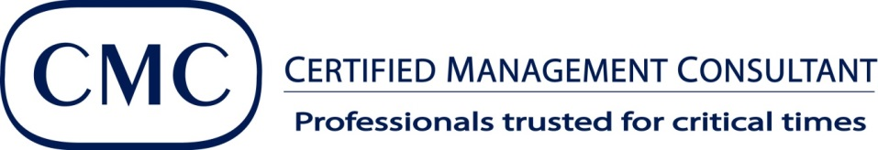

Certified Management Consultants are thought leaders and the drivers of innovation.

CMC’s use their expertise to support clients in multi-sectoral, multi-environmental and multi-jurisdictional settings. As ethically driven professionals, we provide advisory services in many critical areas:
- Strategy/Strategic Management
- Financial Management
- Information Technology, Software, World Wide Web Applications
- HR Management & Training
- Marketing & Sales
- Board Governance
- Operations Management – Quality, BPR, ISO, etc.

Insert IMC Name Here as the guardian of professionalism and standards in Insert your Countryname Here, is the driver for improvement across the management consulting profession, enabling our member CMC’s to increase their impact with clients, plus influence, standing and performance in their ever-changing societies.

Happy International Consultants’ Day to all management consultants and their clients!

For ore information, Please contact:
Name
IMC Name
Address
Phone:
Email:
Website:

